**Router**

# **1. Mesh Coordinate Numbers and Channels**

We are using a 4X4 mesh structure. Hence, the X address would be from 0 to 3, and the Y address from 0 to 3, too.

The coordinate (0,0) is set at the left bottom corner. (3,3) is set at the right top corner.

Here is the diagram:

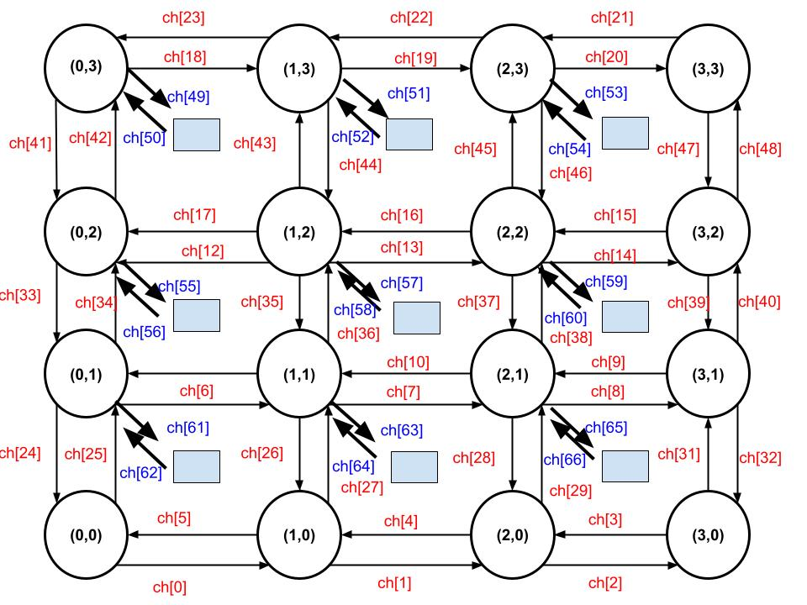

Fig. 4X4 Mesh with Channel Numbers

Based on our mesh structure, we use 4 bits as source address, showing X and Y addresses contain 2 bits respectively. Destination Addresses of X and Y contain 2 bits respectively.

Hence, we use 8 bits to define the packet routing address.

# **2. Router**

The most important part of the router is the routing algorithm. It can be implemented in many ways. Here is my explanation and the structure

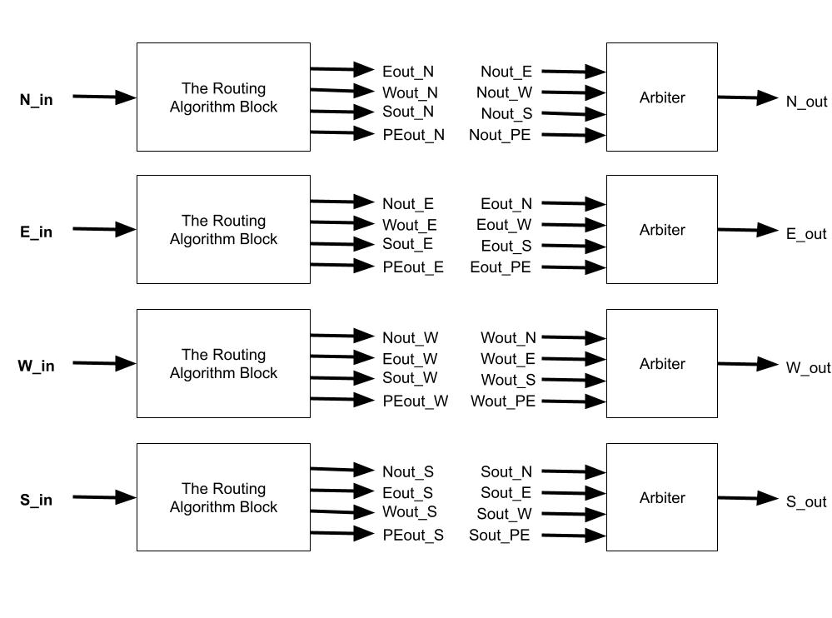

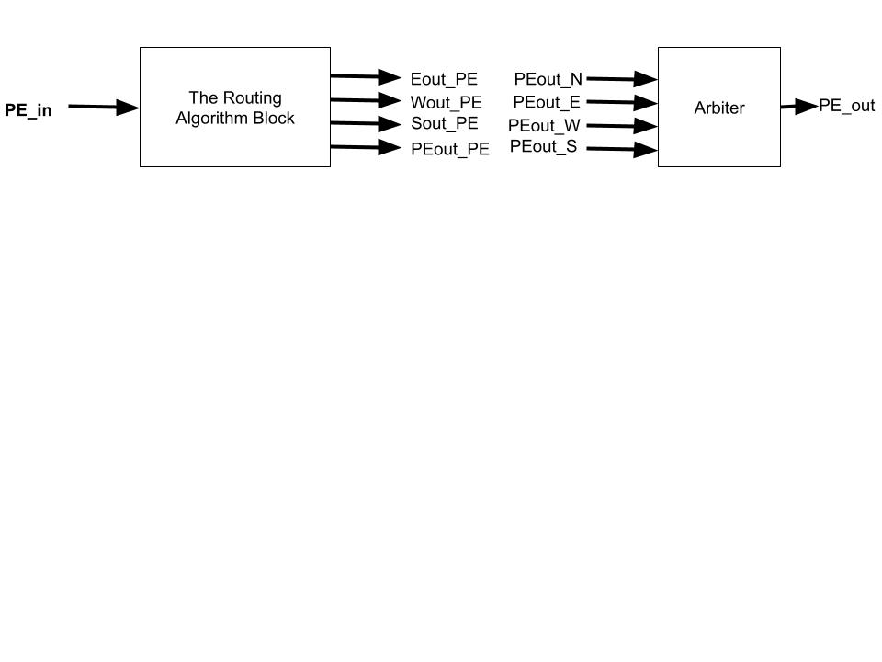

Fig. Router Architecture

First, for a router, it has 5 directions that need to be considered, PE, North, East, West, and South. Each port has input and output. Hence, I define 10 interfaces to implement these dual transmissions in each direction.

But to reduce the level of debugging, I separate each direction as a module. It means I have a module handling the packet from North, East, West, South, and PE direction respectively. Each module contains the routing algorithm block, an arbiter including an output buffer.

About the name of internal channels.Let’s take the North module for example, if this packet is received from the North interface and it will go to PE, I name this channel as PEout_N, and so on.

Let me explain what the ideas are in these blocks and how each block works.

## **(A)North Routing Algorithm Block**

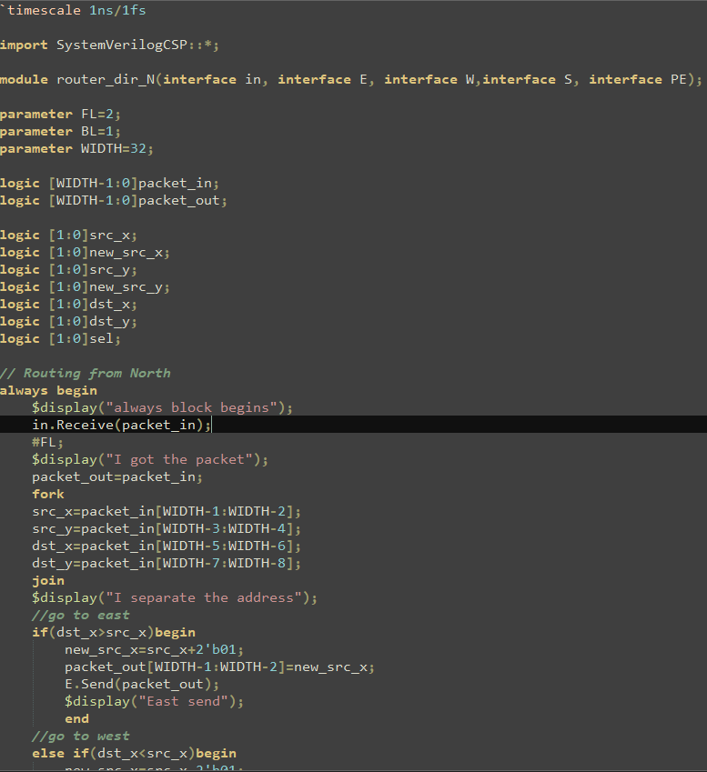

Fig. North Code 1

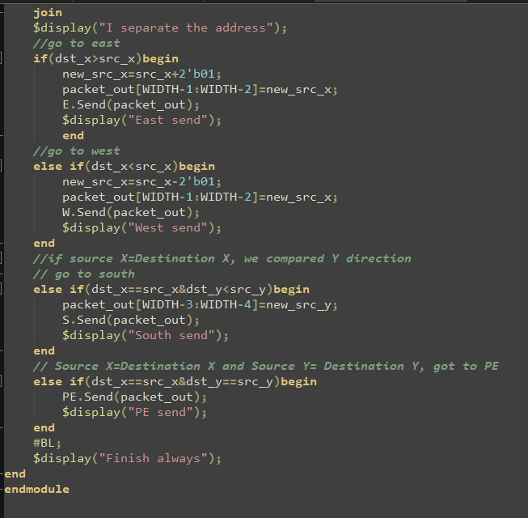

Fig. North Code 1

In this algorithm, I dispacketize the packet to get the source and destination address. After I had the address, I compared the source and destination address. First, I compared the X direction (West and East). If the value of destination X address is larger or smaller than the value of source address, which means the destination position is on the right or left of source position respectively, the packet goes to East or West.

Also, after I determine the direction where the packet should go, I change the source address.